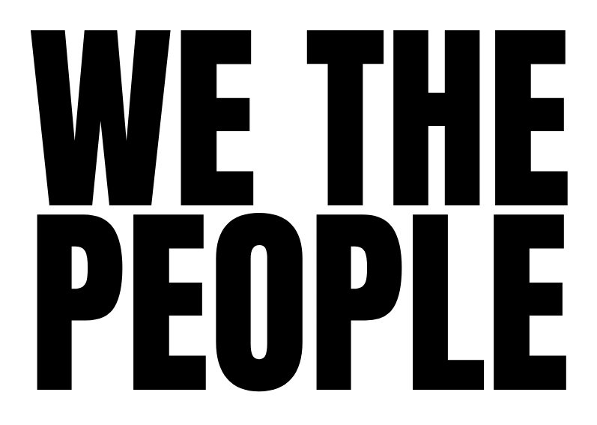

CORE PRINCIPLES

We The People is about putting the interests of humanity - as a collective - first. That means creating a better democratic system for the benefit of everyone, not just a specific party, policy or social group.

This is our foundational first principle.

Beyond that, we seek to uphold other core principles, which act both as guidelines and safeguards for the spirit of our movement. These include:

EVERYONE WELCOME

All are welcome in the movement, whatever their race, gender, class, economic status, religion, political allegiance or any other defining characteristic of identity.

COME AS YOU ARE

We do not ask people to be anything other than who they already are. No prior education, training or ideological commitment is asked for or expected - other than a commitment to our first principle.

DO UNTO OTHERS

We ask those who take an active part in the movement to treat others in the same way they would wish to be treated, with respect, tolerance and empathy.

CURIOUS & OPEN MINDED

In particular, this means being both curious and open-minded. We try not to assume that we know “the truth” or that our version of reality is the only correct one. In meeting others, our attitude aims to be: “What are you seeing that I don’t?”

BOTH / AND

We seek to move beyond the binary, either/or polarities so prevalent in society and remain open to the possibility that two deeply opposed points of view can have value and truth in them.

FORGIVENESS

We allow for people to make mistakes, in present and past, as this is foundational to real change. At the same time, we know forgiveness is a process, not something that can be instantly switched on. We have no rules for how long the process should take.

DEMOCRACY AS A WAY OF LIFE

Those of us active in the movement will try to the best of our ability to embody these principles in our everyday lives, not only when we’re involved in activities for We The People.

HUMAN OVER MACHINE

While we honour the power of technology, including AI, we believe human creativity, intelligence and rights always takes precedence over those of machines.

OUR HIDDEN UNITY

These principles are all expressions of a foundational philosophy, one backed by both quantum physics and ancient wisdom: that beneath the noise of division, a hidden harmony unites us and all of life. Our work aims to uncover it.

Finally, we emphasise that these principles are a kind of “open source” code. They can be adapted, improved or augmented as we move forward.

We The People
2nd June 2026

